**Question 1**

Login to your AWS account. Select “ap-southeast-1” as region. Submit a full-screen screenshot of the AWS EC2 Management Console page from the web browser. [5 Marks]

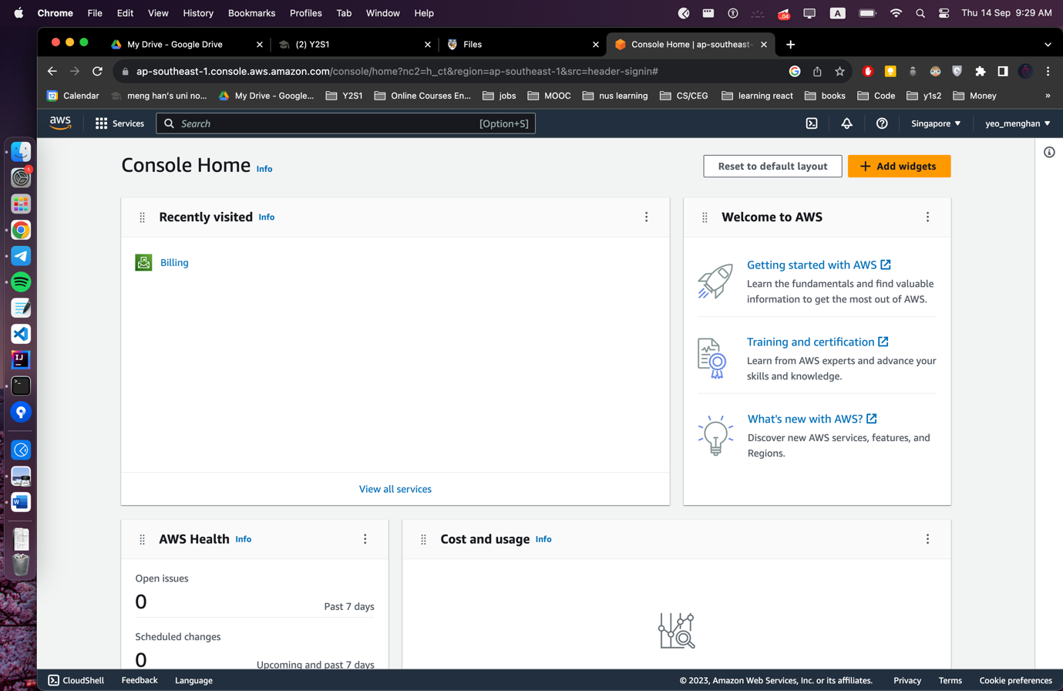

**Question 2**

Refer to the python file lab3.py attached.

**Question 3**

Command given:

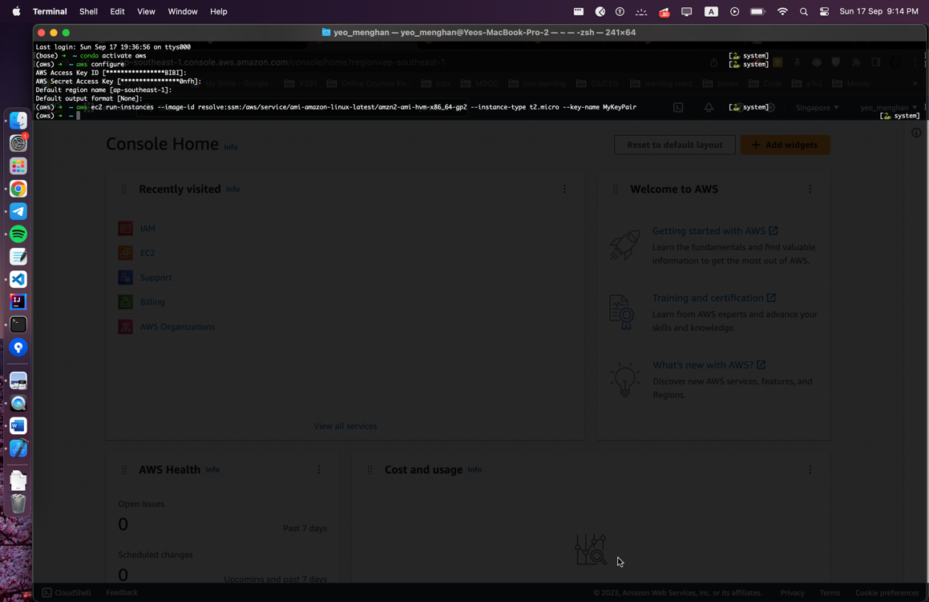

Corresponding output:

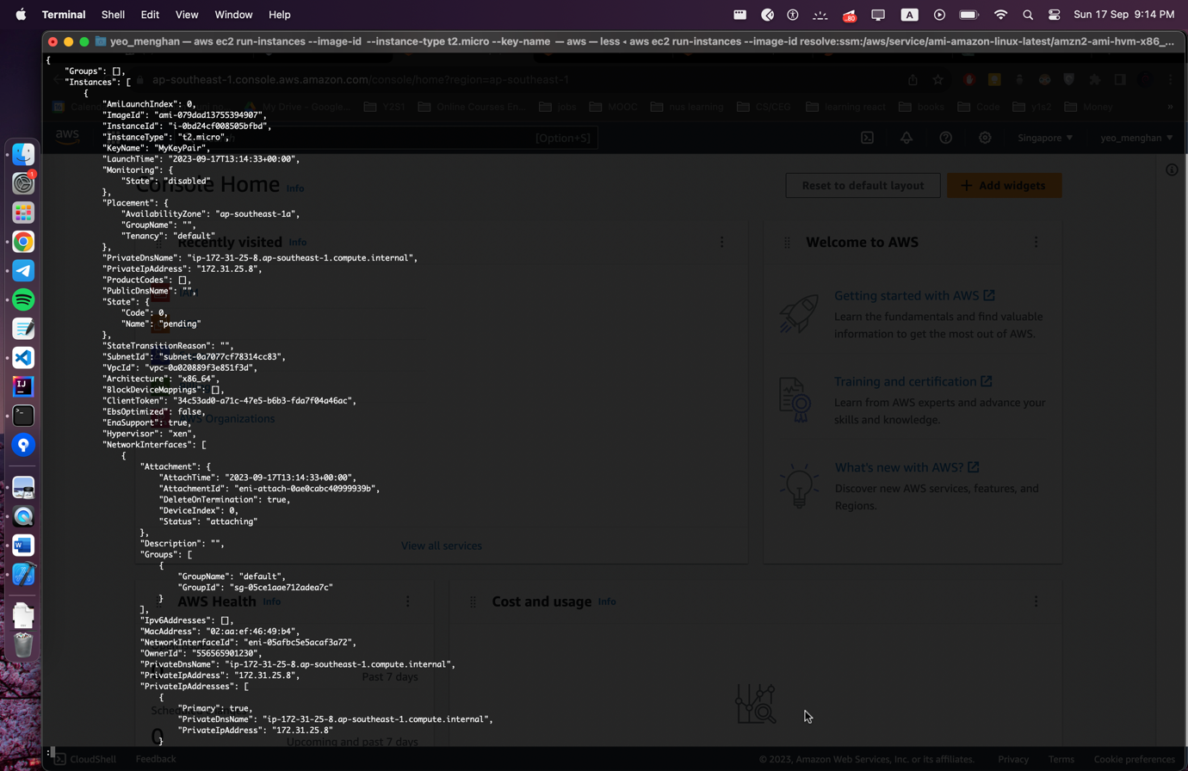

**Question 4**

Command given:

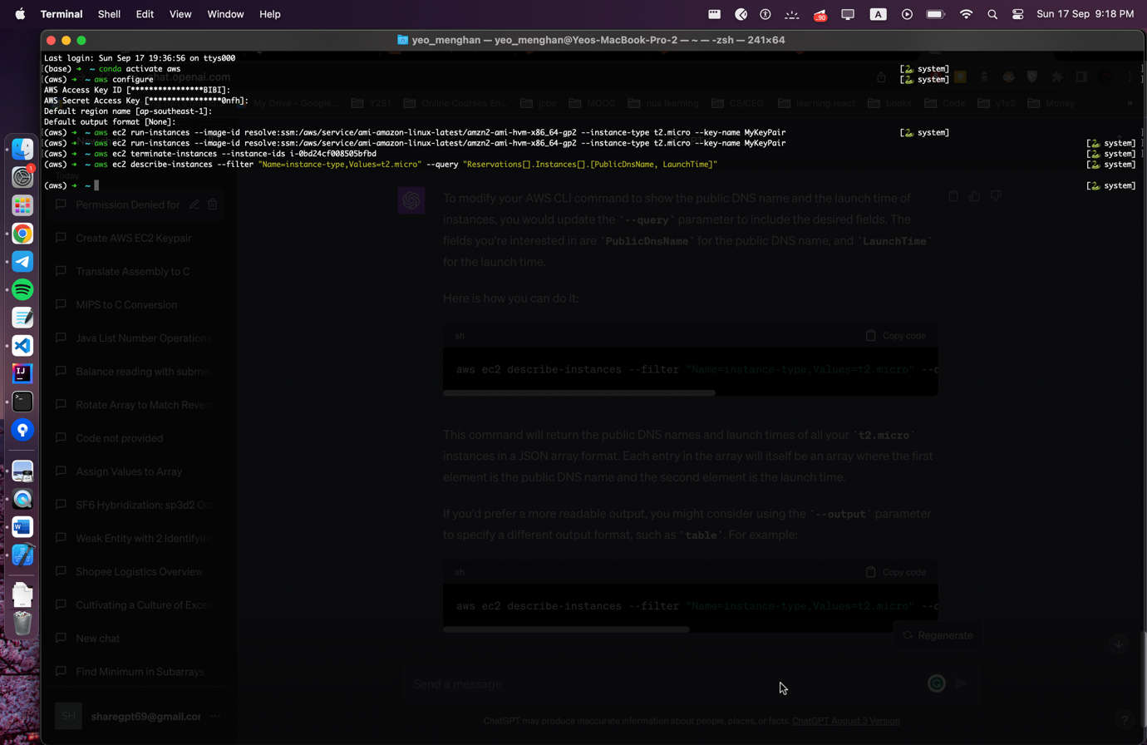

Public DNS name and Launch Time shown:

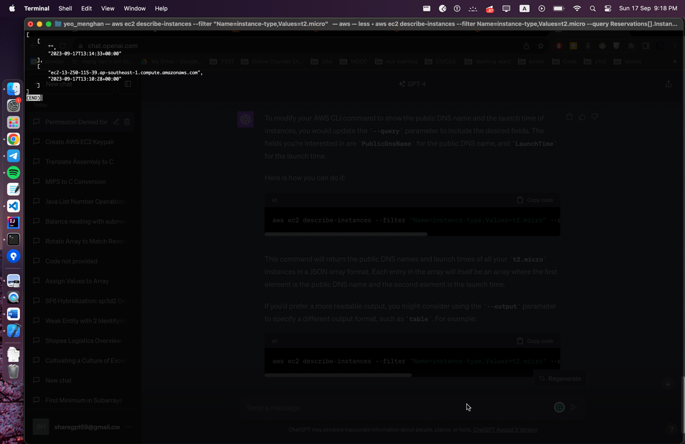

**Question 5**

Scp the python script, FAOSTAT dataset and the keypair via ip address.

Thereafter, ssh into the ip address to check that the python script and dataset has been uploaded to the ec2 instance

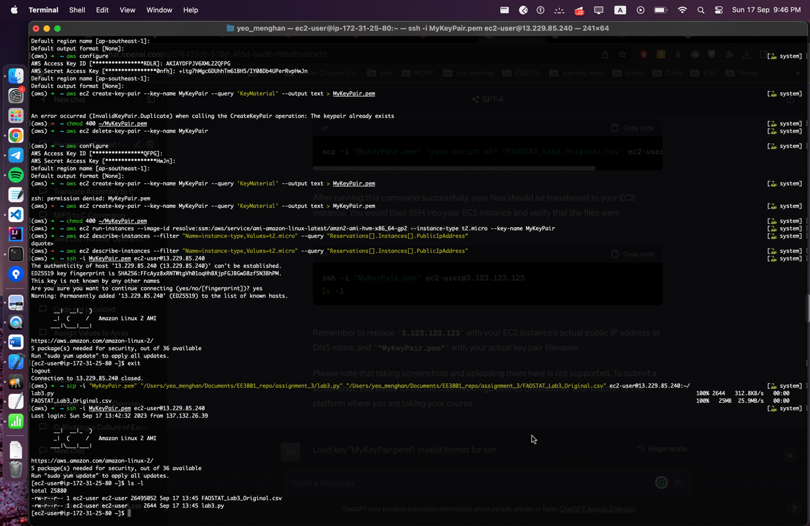

**Question 7**

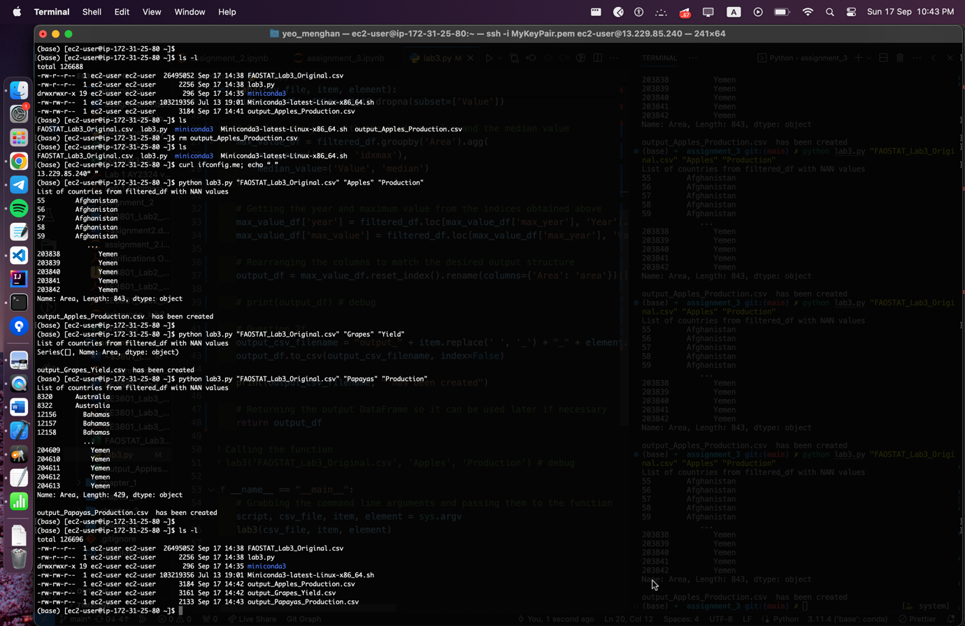

**Question 8**

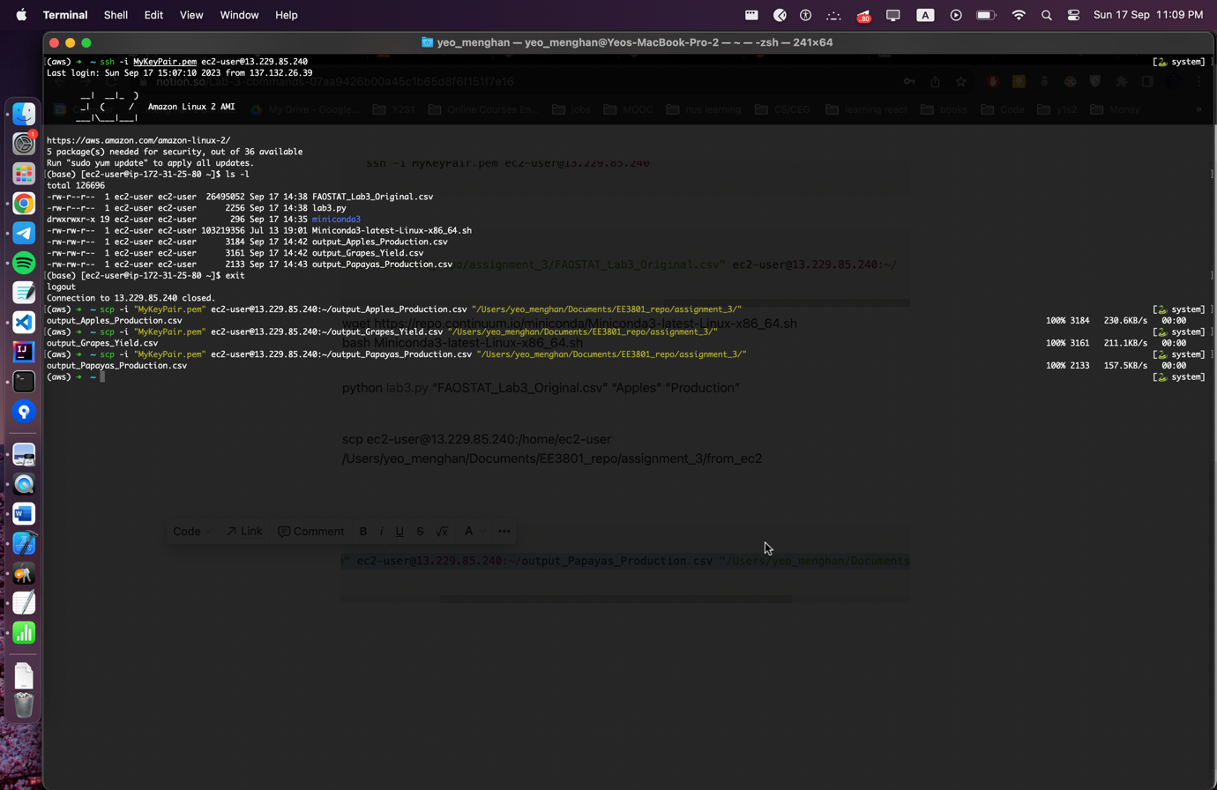

Successfully transferred as shown: 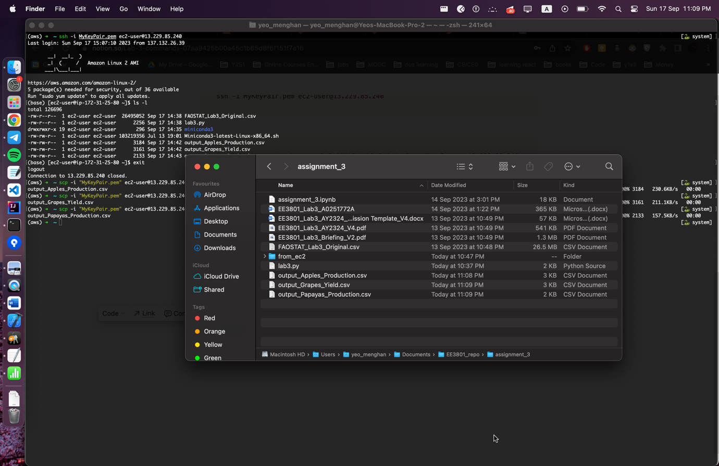

**Question 10**



